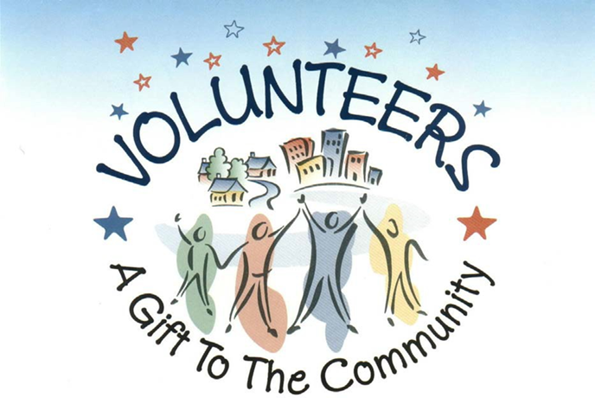

What can I do as a volunteer?
- Interact with patients, visitors, and staff
- Administrative and clerical work
Why should I volunteer?
- The efforts of our dedicated volunteers help maintain quality services and make each person’s stay more enjoyable
- Opportunity to put your talents and experience to work
- Become a part of a caring, compassionate, and friendly team
- Feel a sense of accomplishment and personal satisfaction
- Opportunity to shadow various healthcare professionals and departments
How do you get started?
- Complete an application and submit to the email below. Selected volunteers will be asked to complete the following:
  - Complete a criminal background check. (administered by the Hospital)
  - Complete health screenings and a TB test. (administered by the Hospital)
    - Includes drug test, proof of immunizations for Tetanus, Chicken Pox, MMR, Flu and COVID

CONTACT: Food & Nutrition and Volunteer Services Director (909.394.2719)
or email: ruehlein@primehealthcare.com
VOLUNTEER MEMBERSHIP APPLICATION

Thank you for your interest in becoming a volunteer at Prime Healthcare!

Full Name
Address City State Zip Code
Cell Phone | Email Address
Date of Availability

WORK STATUS: ______Employed ______Retired ______Unemployed ______Student (Must be 18 years or older)
Current occupation: _____________________________________________________________________

YOUR PREFERENCES FOR VOLUNTEER DAYS AND DUTIES
Days of the Week Availability (Check all that apply)  □ Monday □ Tuesday □ Wednesday  □ Thursday □ Friday | Shift Availability (Check all that apply)  □ Morning 8 a.m. to Noon □ Noon to 4 p.m.  □ Other: .

QUESTIONNAIRE:
- How did you learn of this volunteer opportunity?
- Have you volunteered anywhere else? If yes, where and what were your volunteer duties? Are you still a volunteer there?
_____________________________________________________________________________________________________
_____________________________________________________________________________________________________

_____________________________________________________________________________________________________
- Why are you interested in volunteering at a hospital?
_____________________________________________________________________________________________________
_____________________________________________________________________________________________________
_____________________________________________________________________________________________________
- Are there any accommodations needed for you to perform volunteer duties safely and competently?
_____________________________________________________________________________________________________
_____________________________________________________________________________________________________
_____________________________________________________________________________________________________

- How do you make connections with new people?
_____________________________________________________________________________________________________
_____________________________________________________________________________________________________
_____________________________________________________________________________________________________
- Do you belong to any community organization? If yes, which ones?
_____________________________________________________________________________________________________
_____________________________________________________________________________________________________
_____________________________________________________________________________________________________
- SKILLS/WORK EXPERIENCE:
____Accounting ____Leadership ____Computer ____Nursing ____Teaching ____Public Speaking

- Are there any skills, abilities, or hobbies that you’re proud of? Example: crafts, music, sports, computer skills, art, etc.
_____________________________________________________________________________________________________
_____________________________________________________________________________________________________

_____________________________________________________________________________________________________
- Do you speak/write/read another language fluently? _____ Language: ___________________________

- Do you know someone employed at a Prime Healthcare facility? [ ] Yes [ ] No

If yes, how are they related to you? _______________________________________________________________________

If yes, what’s their name, hospital, and department? _________________________________________________________

________________________________________________________ _

EMERGENCY INFORMATION
Emergency Contact Name Relationship to you
Cell Phone Work Phone

VOLUNTEER RELEASE

As a volunteer of Prime Healthcare, I agree to abide by all its rules and regulations. I also agree to perform my assigned duties in a courteous and dependable manner to the best of my ability.
I understand my obligation to protect patients, families, and members of Prime Healthcare’s staff from improper disclosure of confidential information regardless of its source (i.e., the spoken word, the medical record/patient chart, computer records, financial reports, statistical data, minutes of meetings, personnel files, or other records). Furthermore, I agree that I will not access any information which is not directly related to the performance of my duties.
Violation of any Prime Healthcare policy, especially the confidentiality policy, will be considered a breach of Prime Healthcare’s Code of Ethics and will result in termination of my service.
Volunteer Signature: ______ _ Date: ______________________
Volunteer Print Name: ____________________________________

